Figure 1: Program.cs (server side)

Figure 2: Public quiz search (Blue = client side, yellow = server side)

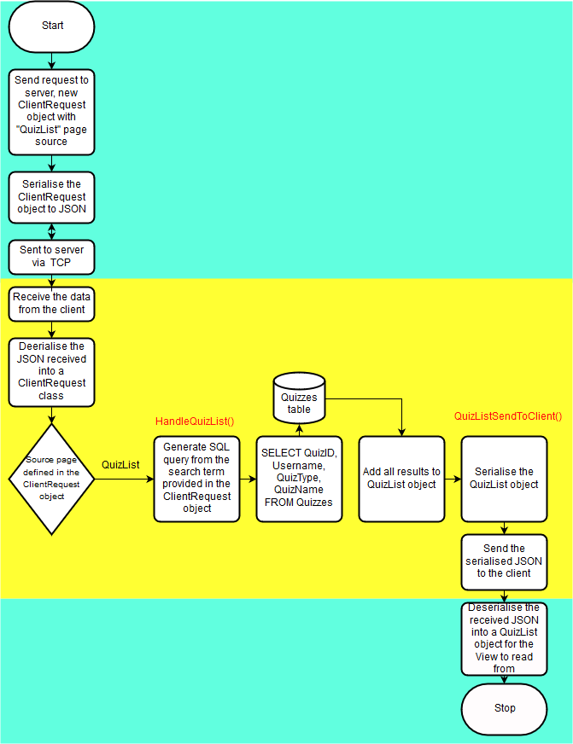

Figure 3: ShellViewModel.cs

Figure 4: Event aggregation algorithm (Red = ShellViewModel.cs, blue = any other view model)

